3GPP TSG-RAN WG4 Meeting #119 R4-2606862

Dalian, China, May 18th – 22nd, 2026

Title: Discussion on testability of sensing for 6GR
Source: Samsung
Agenda item: 8.10.6
Document for: Approval

Introduction
In RAN#108, the Integrated Sensing and Communication (ISAC) on 6G Radio (6GR) has been approved as a new study item ^{[1,2]}, where RAN4 working group is expected to study and discuss the physical functions and procedures, RF, coexistence, and testability for radio sensing.
- Sensing – Studies to be based on use cases and associated requirements, as defined in [TR38.914]
- PHY functions and procedures for sensing technology (e.g., waveform. reference signals, measurement feedback, etc…) [RAN1, RAN4]
- Evaluate sensing performance and if necessary, extend channel modelling, for the selected use cases [RAN1]
- Aspects of integration with communication services [RAN1]
- higher layer procedures and protocol aspects [RAN2]
- RAN4 aspects of sensing including RF, coexistence, and testability in coordination with other WGs [RAN4]
Note: RAN1 identify detailed requirements, if triggered by TSG RAN
In RAN#109, the key performance indicators and use cases of ISAC have been discussed, and the core technical performance requirements and basic use cases have correspondingly added to TR38.914 ^{[3]}. Further, in RAN#111 meeting, the use case of 6G sensing was discussed and a new use case is included in 6G sensing study ^{[4,5]}.

5.4.4 Sensing
Editor note: More sensing use cases can be included depending on further discussion.
The 6GR and 6G RAN architecture shall at least support use cases of
- detection and/or tracking of passive objects, at least including UAVs, human, vehicles and AGVs
- communication assistance.
In this contribution, the discussion of testability for 6G sensing in RAN4#118bis meeting is resubmitted.

Discussion
Generally, the testability related items are highly RAN4 dominant. In this section, the testing related methodology for 6G sensing is discussed to promote RAN4 6G sensing discussion.

2.1 Testing Methodology
Current 5G NR specifications have defined two types of tests for communication systems, i.e., conductive test, and radiated test, to measure their RF performance. For the conductive test, the RF parameters are measured at transceiver array boundary (TAB) ^{[6]}. However, the evolution of mmWave and massive Multiple-Input Multiple-Output (MIMO) techniques has resulted in a significant change in RF devices/components, which are not suitable for conductive test any more. To guarantee the RF performance of mmWave and massive-MIMO supporting devices, radiated test is introduced to measure the RF performance in an over-the-air (OTA) way.
Although the frequency range of 6G sensing systems has not been decided yet, it is highly likely that both FR1 and FR2-1 will be utilized for sensing operations. Therefore, it is reasonable to consider both conductive test and radiated test for 6G sensing RF performance measurement.
- RAN4 to consider both conductive test and radiated test for 6G sensing RF performance measurement.
For the conductive test, it is recommended that RAN4 to adopt the following test procedure as starting point.
- RAN4 to adopt the test procedure shown in Figure 2.1-1 as starting point for 6G sensing conductive test.
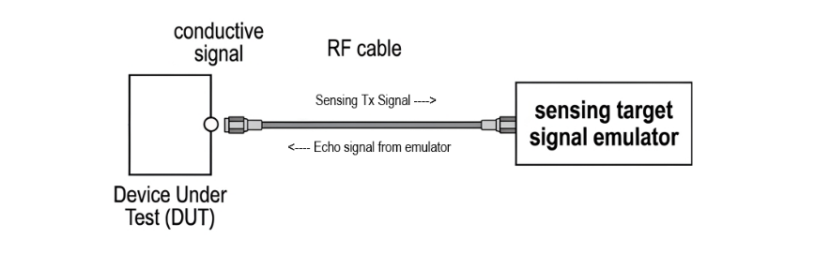
Figure 2.1-1 Illustration of 6G sensing conductive test procedure
For the radiated test, it is recommended that RAN4 to adopt the following test procedure as starting point.
- RAN4 to adopt the test procedure shown in Figure 2.1-2 as starting point for 6G sensing radiated test.
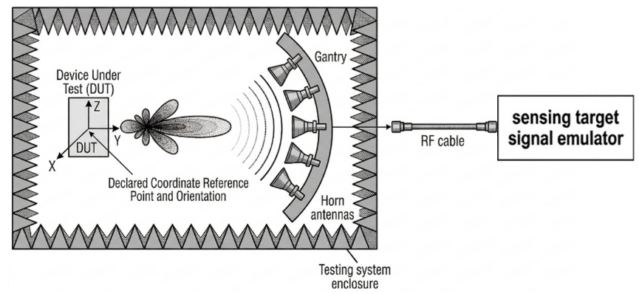
Figure 2.1-2 Illustration of 6G sensing radiated test procedure

Conclusion
In this contribution, we proposed following for the general aspects and regulatory requirement survey for 6G sensing:
- RAN4 to consider both conductive test and radiated test for 6G sensing RF performance measurement.
- RAN4 to adopt the test procedure shown in Figure 2.1-1 as starting point for 6G sensing conductive test.

Figure 2.1-1 Illustration of 6G sensing conductive test procedure
- RAN4 to adopt the test procedure shown in Figure 2.1-2 as starting point for 6G sensing radiated test.

Figure 2.1-2 Illustration of 6G sensing radiated test procedure

References
- RP-251861 “New SID: Study on Integrated Sensing and Communication (ISAC) for NR,” RAN#108
- RP-251881, “New SID: Study on 6G Radio,” NTT DOCOMO (Moderator), 3GPP TSG RAN Meeting #108, Prague, Czech Republic, June 9-13, 2025.
- RP-252882 “TR38.914 ‘Study on 6G Scenarios and Requirements (Release 20)’”
- RP-260819 “Moderator's summary for RAN led 6G SI: Requirements of new and existing services”, Moderator (CMCC), 3GPP TSG RAN Meeting #111, Fukuoka, Japan, March 9-12, 2026.
- RP‑260073 “TR38.914 ‘Study on 6G Scenarios and Requirements (Release 20)’”
- 3GPP TS 38.104, “NR; Base Station (BS) Radio Transmission and Reception”

